Test Summary for Lab 8

(Shruti Ratna Charugulla)

Purpose 1

Overview of SideeX 1

Tests Executed 2

Automation Testing – Record and Playback 2

Metrics 3

Test Cases 3

Defects 3

Test Environment and Tools 4

Exit Criteria 4

Conclusion/Sign off 4

## Purpose

This report provides a summary of the testing conducted to verify the proper page load for multiple pages loaded by verifying the title of each web page that gets loaded.

## Overview of SideeX

SideeX is an open source record-playback-style web application testing tool. It is an extended version of Selenium IDE with a number of expanded automation capabilities. It runs as an extension in both Chrome and Firefox browsers. Below is a snapshot of the SideeX’ graphical user interface.

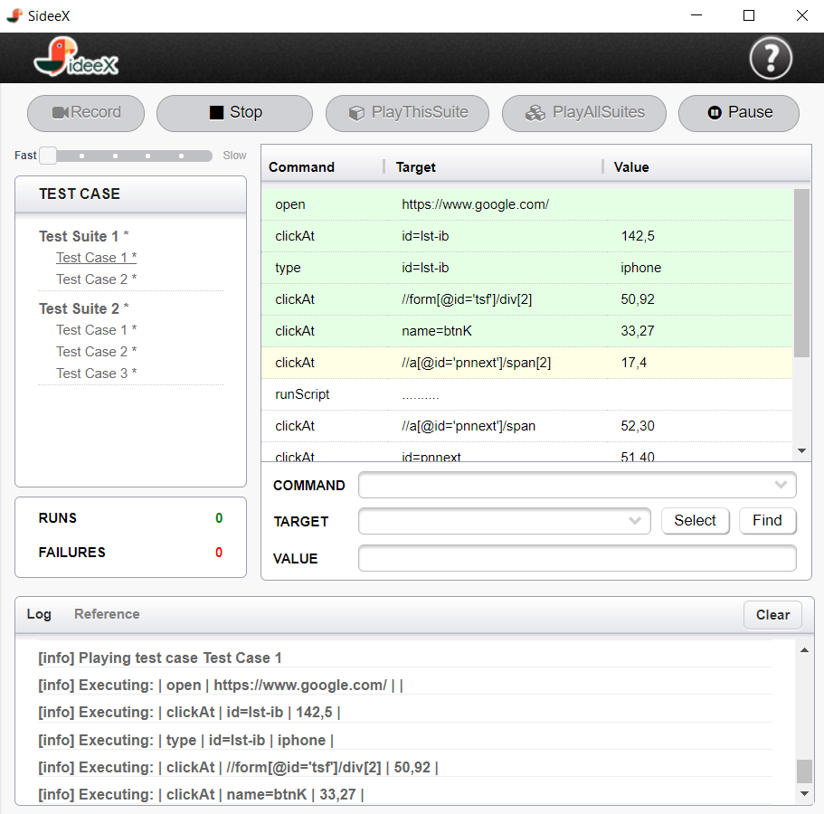

## Tests Executed

### Automation Testing – Record and Playback

The test cases listed below was recorded using the record feature in SideeX application:

#### Test Case 1:

1. Navigate to the webpage <https://www.wholefoodsmarket.com/>.
2. Navigate to the SideeX command line and left click on the X, then scroll down.
3. Left click on “verify title”, and in the “Value” field type “Whole Foods Market| America’s Healthiest Grocery store”.

#### Test Case 2:

1. Click on the 1st Tab, “Coupons”.
2. Navigate to the SideeX command line and left click on the X, then scroll down.
3. Left click on “verify title”, and in the “Value” field type “My Rewards | Whole Foods Market”.

#### Test Case 3:

1. Click on the 2nd Tab, “Local Sales”.
2. Navigate to the SideeX command line and left click on the X, then scroll down.
3. Left click on “verify title”, and in the “Value” field type “Local Sales| Whole Foods Market”.

#### Test Case 4:

1. Click on the 3rd Tab, “Recipes”.
2. Navigate to the SideeX command line and left click on the X, then scroll down.
3. Left click on “verify title”, and in the “Value” field type “3,978 Recipes for Delicious Food | Whole Foods Market ”.

#### Test Case 5:

1. Click on the 4th Tab, “Shop Online”.
2. Navigate to the SideeX command line and left click on the X, then scroll down.
3. Left click on “verify title”, and in the “Value” field type “Online Ordering And Catering | Whole Foods Market”.

#### Test Case 6:

1. Click on the 5th Tab, “Customer Service”.
2. Navigate to the SideeX command line and left click on the X, then scroll down.
3. Left click on “verify title”, and in the “Value” field type “Customer Service| Whole Foods Market”.

The test cases were saved into a Test suite with the name –“Lab 8 – Shruti Charugulla” and then the test suite was played back to verify if the test cases were executed successfully.

## Metrics

### Test Cases

|  |  |  |  |
| --- | --- | --- | --- |
| Test Cases Planned | Test Cases Executed | TCs Passed | TCs Failed |
| 6 | 6 | 6 | 0 |

### Defects

None

## Test Environment and Tools

Below is a table that includes a brief overview of the software and hardware setups used to execute the test cases described in this report.

|  |  |
| --- | --- |
| Automation testing tool | SideeX |
| Computer hardware | 2.3 GHz Intel Core i5, 4GB RAM |
| OS | OS X El Capitan Version 10.11.1 |

## Exit Criteria

* The planned test cases need to be passed.
* No critical defects found.
* The recorded test suite successfully played back.

## Conclusion/Sign off

All exit criteria were met and satisfied.